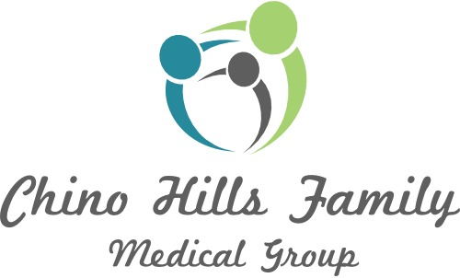

MEDICAL RECORDS REQUEST

Patient’s Name______________________________________________________________________________
Date of Birth___________________________ Social Security (optional)________________________________
Phone #______________________________________ Cell #_________________________________________
I hereby request my medical records to be sent:
FROM: Chino Hills Family Medical Group
15361 Central Ave.
Chino, CA 91710

TO: ____ SELF
____ OTHER __________________________________________________________________
_________________________________________________________________
_________________________________________________________________

Reason for request: __________________________________________________________________________

Requesting: ____ Entire Record ____ Specific Information____________________________________

**I give permission to release any information regarding: (initial each line below if you grant permission to obtain records)

____ Substance Abuse ____Psychiatric Mental Health Information ____HIV/AIDS information

Restrictions: I understand the recipient may not further use or disclose the medical information unless another authorization is obtained from me or unless such use or disclosure is specifically required or permitted by law.
Additional Copy: I further understand that I have the right to receive a copy of this authorization upon my request.

SIGNED:___________________________________, ___________________________ DATE:________________
(If not patient, state relationship)

